**FRONT SHEET**

|  |  |  |  |
| --- | --- | --- | --- |
| **Subject:** Airline Reservation System | | | |
| **Coursework title:** Database Systems | | | |
| **Course Teacher:** Ma’am Tayyaba Farhat | | | |
| Team Members:   1. Zunaira Javaid (BSEM-F19-090) (Leader) 2. Vaneesa (BSEM-F20-104) 3. Noman (BSEM-F20-120) | | | |
| Submission Date: 9/12/2022. | | | |
| Number of words used: 1478 (please insert number of words**)**  **Format**  The coursework should be typed in 12-point font, lines spaced at 1½ or double spacing.  Standard cover sheet should be attached. In addition, a title page and **Marking Scheme for the coursework** (which is given towards the end of this coursework) should be attached. | | | |
| By submitting this coursework, I certify this to be my own work. I understand that if this is untrue I will have committed an assessment offence e.g. plagiarism within the College regulations and that disciplinary proceedings may be brought against me. | | | |
| Student’s signature: | * Zunaira Javaid (090) * Vaneesa (104) * Noman (120) | Date: | 9/12/2020 |

**This form must be used as the front sheet of your coursework**

Database Project

**Course:** Database Systems

Project on Database Applications

**Prepared for: Ma’am Tayyaba Farhat**

**Date: /12/2020**

**Prepared by:**

1. Zunaira Javaid (090) (Leader)
2. Vaneesa(104)
3. Noman (120)

**Section:** BSSE-4A

“This assignment is my own work. The sources of all quotations, both direct and indirect, have been fully cited; All material used in the preparation of this assignment has been acknowledged. This assignment has not been submitted for assessment in any other paper.”

Signed by:

|  |  |  |
| --- | --- | --- |
|  |  |  |

**Table of Contents**

Introduction 4

Arline Reservation System Case Study 4

The Entity Relationship Diagram 5

Schema Map 6

Table Plans 6

SQL (DDL) 10

SQL (DML) 12

SQL Query 16

Conclusion 21

List of tasks assigned: 21

## Introduction

The **Arline Reservation System** is a system which is especially design for the passengers who can’t come to airline offices for bookings. This system provides our customer an ease to book their tickets at their own place. This system provides different features for our passengers like availability of seats and tickets, ticket prices of different airlines and different packages of airline tickets etc. We can say that Airline Reservation System is a system where you can do any kind of airline booking within minutes.

## Arline Reservation System Case Study

The **Airline Reservation System** covered all the features such as flight scheduling, departure and arrival time of a plane, seat reservations and airline packages. This system extensively covered all the things which passengers seen many times in booking their airline tickets.

After the complete analysis of airline reservation system, we come to know about the necessary entities and attributes which are as following:

* **Entity:** Details_of_Airline.

**Attributes:** id_of_airline (pk), name_of_airline, total_no_of_seats, from_location, to_location, departure_time, arrival_time, flight_duration.

* **Entity:** Det_Airline_Flight.

**Attribues:**id_of_airline(fk), flight_id(fk), cpk(id_of_airline,flight_id)

* **Entity:** Flight.

**Attributes:** flight_id (pk), departure_date, price_of_ticket, available_economy_seats, available_vip_seats.

* **Entity:** Flight_and_Ticket.

**Attributes** flight_id(fk), ticket_id(fk), cpk(flight_id,ticket_id)

* **Entity:** Ticket_Booking_Info.

**Attributes:** ticket_id (pk), status_of_ticekt.

* **Entitiy:**Passenger_and_Ticket.

**Attributes:** flight_id(fk), passenger_id(fk), cpk(flight_id,passenger_id)

* **Entity:** Passenger_Info.

**Attributes:** passenger_id (pk), first_name, middle_name, last_name, age, gender, phone_no, cnic_no, email_id,passenger_type, nationality, religion.

* **Entity:** Payment_Details.

**Attributes:** passenger_id (fk), payment_card_type, payment_card_no, card_expiry.

## The Entity Relationship Diagram

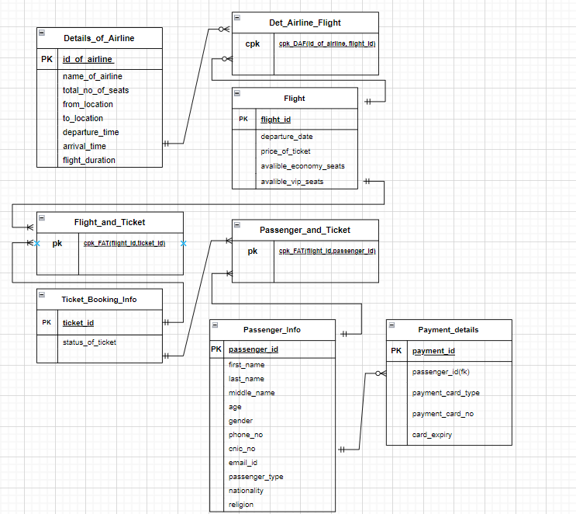

## Schema Map

## Table Plans

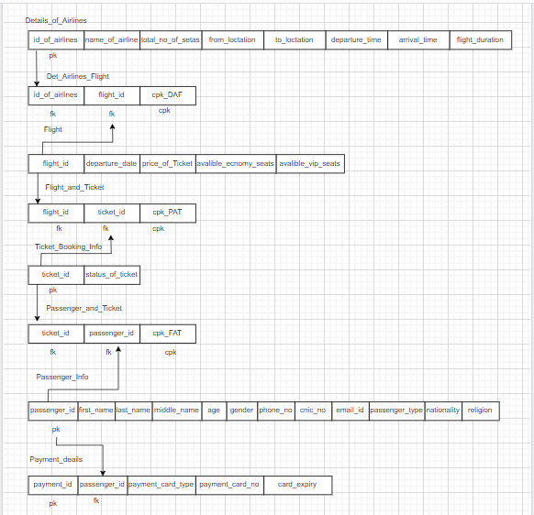

**Details_Of_Airline:**

|  |  |  |  |  |  |  |  |
| --- | --- | --- | --- | --- | --- | --- | --- |
| **Column Name** | **Data type** | **Length** | **Nulls** | **Key Type** | **References** | | **Other Constraints?** |
| **FK Table** | **FK Column** |
| id_of_airline | int |  |  | primary |  |  | Identity(1,1) |
| name_of_airline | nvarchar | 30 | not null |  |  |  |  |
| total_no_of_seats | int |  | not null |  |  |  |  |
| from_location | nvarchar | 50 | not null |  |  |  |  |
| to_location | nvarchar | 50 | not null |  |  |  |  |
| departure_time | time |  | not null |  |  |  |  |
| arrival_time | time |  | not null |  |  |  |  |
| flight_duration | nvarchar | 20 | not null |  |  |  |  |

**Flight**

|  |  |  |  |  |  |  |  |
| --- | --- | --- | --- | --- | --- | --- | --- |
| **Column Name** | **Data type** | **Length** | **Nulls** | **Key Type** | **References** | | **Other Constraints?** |
| **FK Table** | **FK Column** |
| flight_id | int |  |  | Primary key |  |  | identity (1,1) |
| departure_date | date |  | not null |  |  |  |  |
| price_of_ticket | money |  | not null |  |  |  | default |
| available_economy_seats | int |  | not null |  |  |  |  |
| available_vip_seats | int |  | not null |  |  |  |  |

**Det_Airline_Flight**

|  |  |  |  |  |  |  |  |
| --- | --- | --- | --- | --- | --- | --- | --- |
| **Column Name** | **Data type** | **Length** | **Nulls** | **Key Type** | **References** | | **Other Constraints?** |
| **FK Table** | **FK Column** |
| id_of_airline | int |  |  | Foreign  key | Details_Of_Airline | id_of_airline |  |
| flight_id | int |  |  | Foreign  key | Flight | flight_id |  |
| cpk_DAF |  |  |  | composite primary key |  |  | composite key of id_of_airline and flight_id |

**Ticket_Booking_Info**

|  |  |  |  |  |  |  |  |
| --- | --- | --- | --- | --- | --- | --- | --- |
| **Column Name** | **Data type** | **Length** | **Nulls** | **Key Type** | **References** | | **Other Constraints?** |
| **FK Table** | **FK Column** |
| ticket_id | int |  |  | Primary  key |  |  | identity (1,1) |
| status_of_ticket | nvarchar | 50 | not null |  |  |  |  |

**Flight_And_Ticket**

|  |  |  |  |  |  |  |  |
| --- | --- | --- | --- | --- | --- | --- | --- |
| **Column Name** | **Data type** | **Length** | **Nulls** | **Key Type** | **References** | | **Other Constraints?** |
| **FK Table** | **FK Column** |
| flight_id | int |  |  | Foreign  key | Flight | flight_id |  |
| ticket_id | int |  |  | Foreign  key | Ticket_Booking_Info | ticket_id |  |
| cpk_FAT |  |  |  | composite primary key |  |  | composite key of flight_id and ticket_id |

**T15_Passenger_Info**

|  |  |  |  |  |  |  |  |
| --- | --- | --- | --- | --- | --- | --- | --- |
| **Column Name** | **Data type** | **Length** | **Nulls** | **Key Type** | **References** | | **Other Constraints?** |
| **FK Table** | **FK Column** |
| passenger_id | int |  |  | primary |  |  | identity (1,1) |
| first_name | nvarchar | 50 | not null |  |  |  |  |
| middle_name | nvarchar | 50 | null |  |  |  |  |
| last_name | nvarchar | 50 | not null |  |  |  |  |
| age | int |  | not null |  |  |  |  |
| gender | nvarchar | 20 |  |  |  |  |  |
| phone_no | nvarchar | 12 | not null | unique |  |  | check |
| cnic_no | nvarchar | 15 | not null | unique |  |  | check |
| email_id | nvarchar | 100 | not null | unique |  |  | Check |
| passenger_type | nvarchar | 50 | not null |  |  |  |  |
| nationality | nvarchar | 50 | not null |  |  |  |  |
| religion | nvarchar | 40 | not null |  |  |  |  |

**T15_Passenger_And_Ticket**

|  |  |  |  |  |  |  |  |
| --- | --- | --- | --- | --- | --- | --- | --- |
| **Column Name** | **Data type** | **Length** | **Nulls** | **Key Type** | **References** | | **Other Constraints?** |
| **FK Table** | **FK Column** |
| passenger_id | int |  |  | Foreign  key | Passenger_Info | passenger_id |  |
| ticket_id | int |  |  | Foreign  key | Ticket_Booking_Info | ticket_id |  |
| cpk_PAT |  |  |  | composite primary key |  |  | composite key of passenger_id and ticket_id |

**T15_Payment_Details**

|  |  |  |  |  |  |  |  |
| --- | --- | --- | --- | --- | --- | --- | --- |
| **Column Name** | **Data type** | **Length** | **Nulls** | **Key Type** | **References** | | **Other Constraints?** |
| **FK Table** | **FK Column** |
| payment_id | int |  |  |  |  |  |  |
| passenger_id | int |  |  | Foreign  key | Passenger_Info | passenger_id |  |
| payment_card_type | nvarchar | 30 | not null |  |  |  |  |
| payment_card_no | nvarchar | 30 | not null |  |  |  |  |
| card_expiry | date |  | not null |  |  |  |  |

## SQL (DDL)

**Details_Of_Airline:**

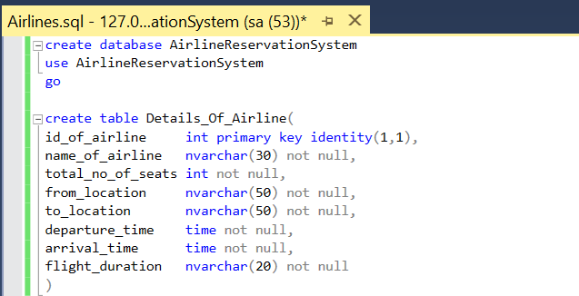

**Flight**

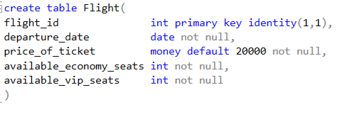

**Det_Airline_Flight**

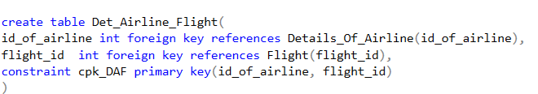

**Ticket_Booking_Info**

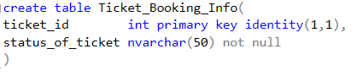

**Flight_And_Ticket**

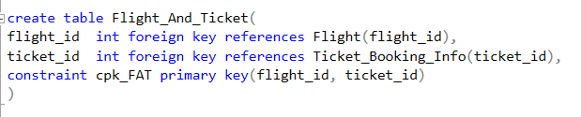

**Passenger_Info**

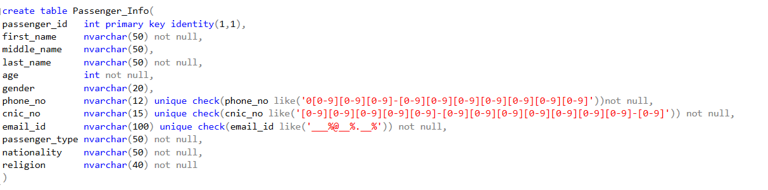

**Passenger_And_Ticket**

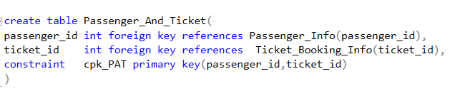

**Payment_Details**

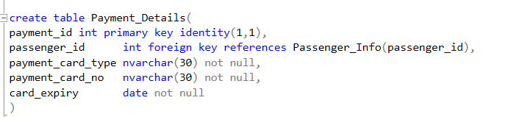

## SQL (DML)

**Details_Of_Airline:**

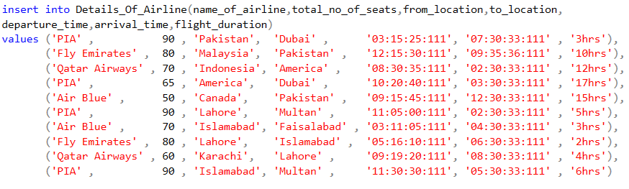

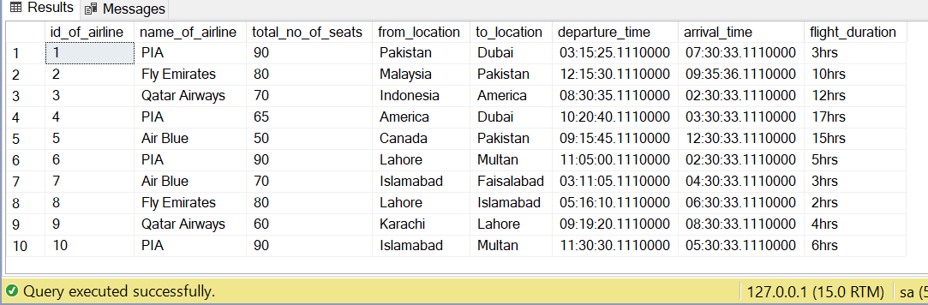

**Flight**

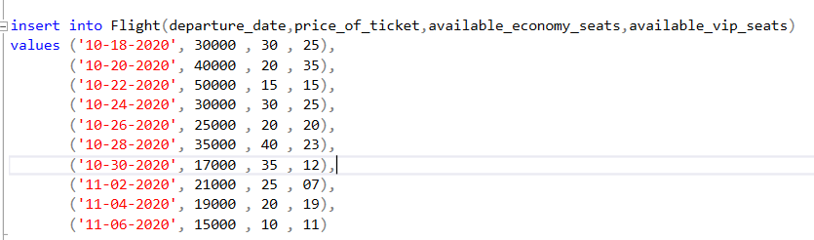

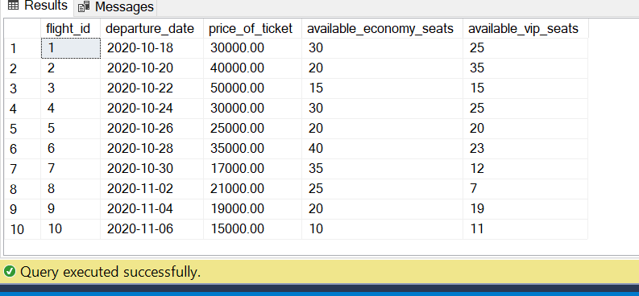

**Det_Airline_Flight**

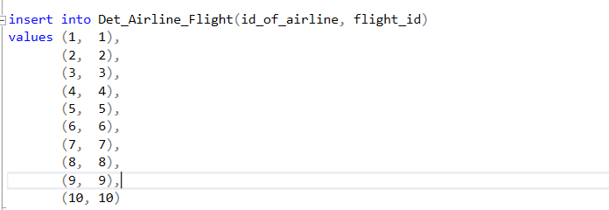

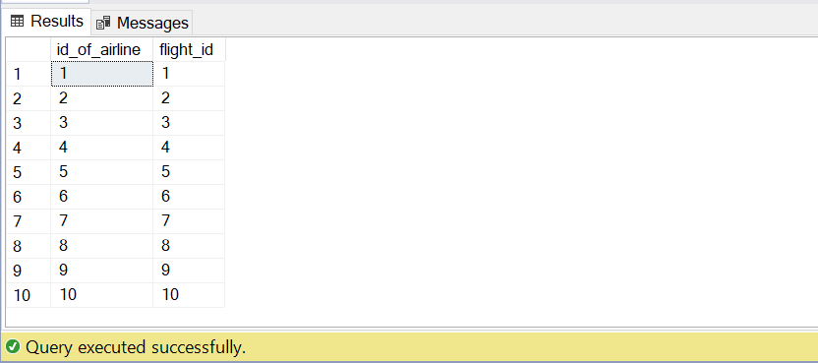

**Ticket_Booking_Info**

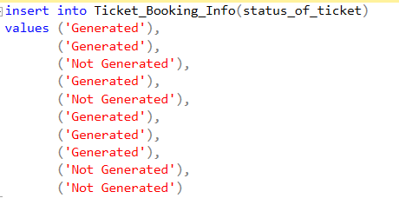

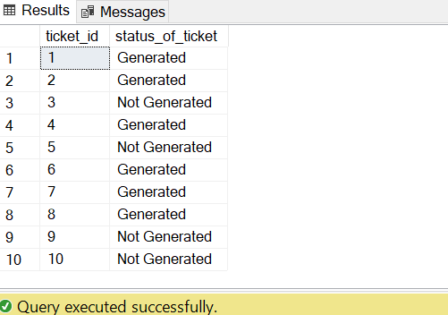

**Flight_And_Ticket**

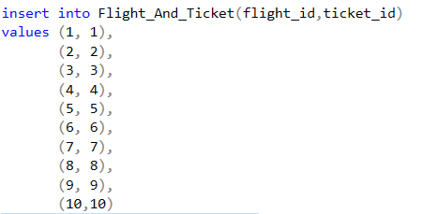

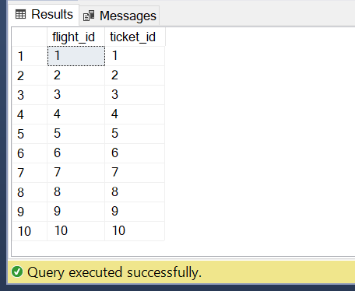

**Passenger_Info**

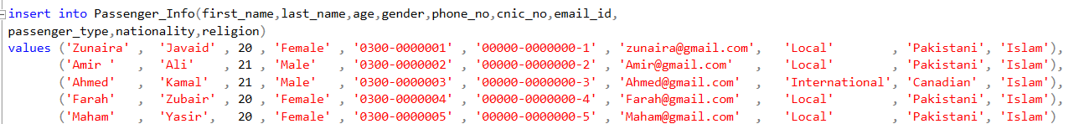

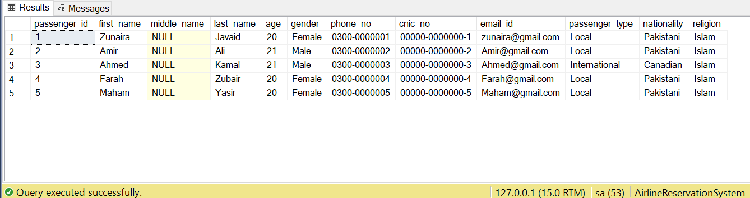

**Passenger_And_Ticket**

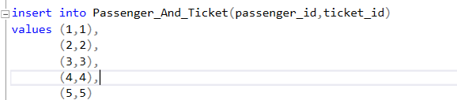

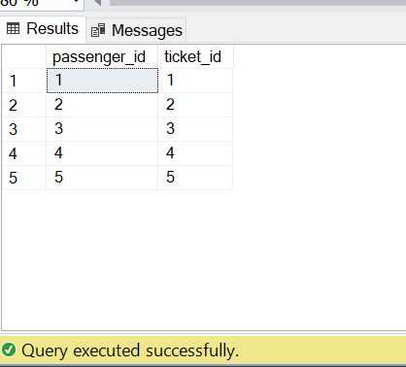

**Payment_Details**

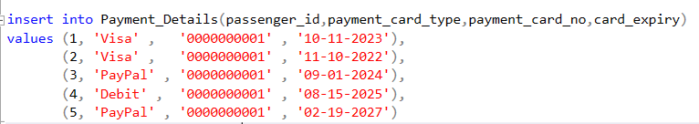

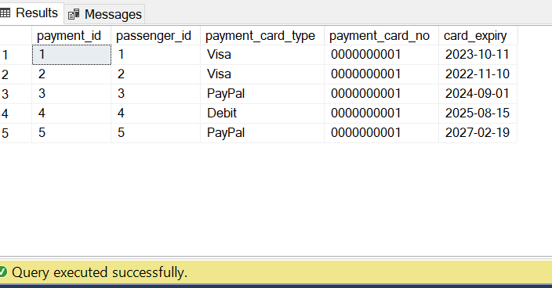

## SQL Query

1. Showing id_of_airline, name_of_airline ,total_no_of_seats, from_location, to_location, departure_time ,arrival_time,flight_duration of table Details_Of_Airline where name_of_airline equal to “PIA”.

select id_of_airline, name_of_airline ,total_no_of_seats, from_location, to_location, departure_time ,arrival_time,flight_duration from

Details_Of_Airline where name_of_airline='PIA'

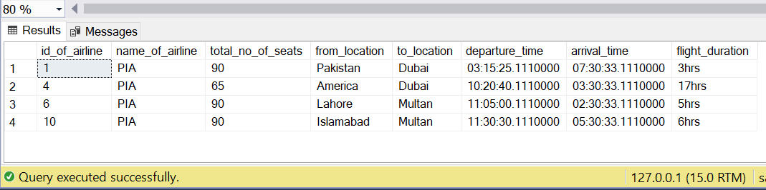

1. Showing id_of_airline, name_of_airline ,total_no_of_seats, from_location, to_location, departure_time ,arrival_time,flight_duration from table Details_Of_Airline where total_no_of_seats is greater than equal to 70.

select id_of_airline, name_of_airline ,total_no_of_seats, from_location, to_location, departure_time ,arrival_time,flight_duration from Details_Of_Airline where total_no_of_seats>=70

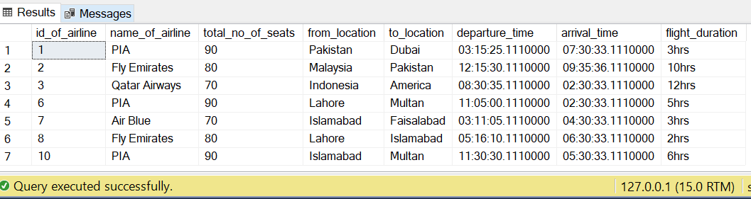

1. Showing flight_id, departure_date, price_of_ticket,available_economy_seats,available_vip_seats from table Flight where available_vip_seats greater than equal to 10 and available_economy_seats are equal to available_vip_seats.

select flight_id, departure_date, price_of_ticket,available_economy_seats,available_vip_seats from Flight where available_vip_seats >=10 and available_economy_seats=available_vip_seats

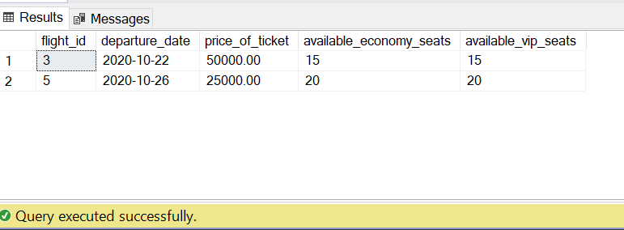

1. Showing flight_id, departure_date, price_of_ticket,available_economy_seats,available_vip_seats from table Flight where price_of_ticket greater than 25000.

select flight_id, departure_date, price_of_ticket,available_economy_seats,available_vip_seats from Flight

where price_of_ticket>25000

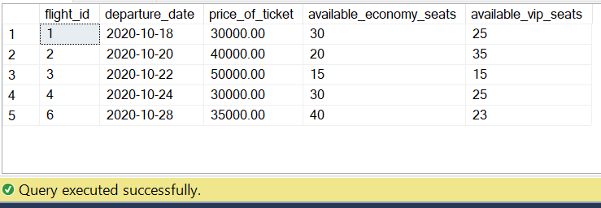

1. Showing passenger_id, first_name,last_name,age,gender,phone_no,cnic_no,email_id,

passenger_type, nationality, religion from table Passenger_Info where gender is equal to “Male” and age=21.

select passenger_id, first_name, last_name,age,gender,phone_no,cnic_no,email_id,passenger_type,

nationality,religion from Passenger_Info where gender='Male' and age=21

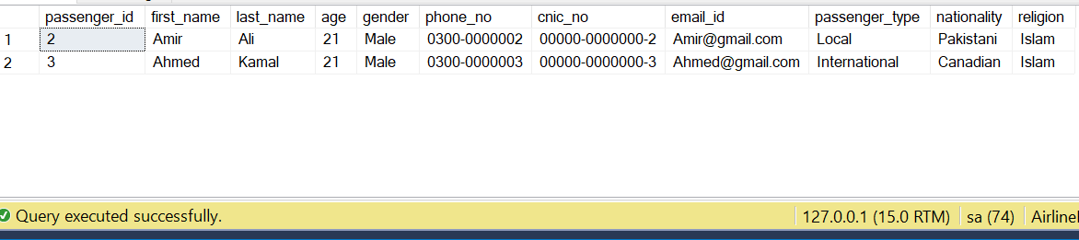

1. Showing total number of airlines from table Details_Of_Airline

Select count(*) as TotalCountAirlines from Details_Of_Airline

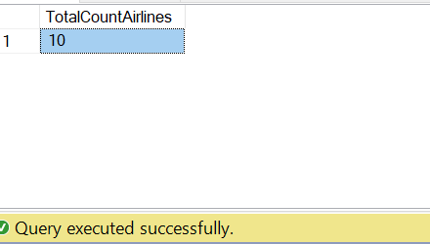

1. Showing total number of economy seats from table Flight

Select count(available_economy_seats) as TotalEcnomyseats from Flight

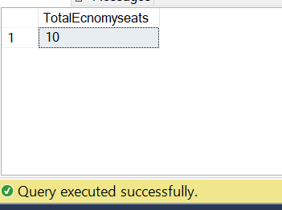

1. Showing total number of vip seats from table Flight

* Select count(available_vip_seats) as TotalVipseats from Flight

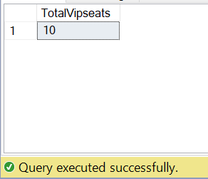

1. Showing name of airline in upper case from table Details_Of_Airline where id =1.

Select upper(ltrim(name_of_airline)) as NameOfAirline from Details_Of_Airline where id_of_airline =1

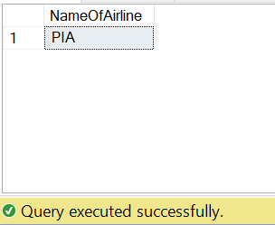

1. Showing name of airline in lower case from table Details_Of_Airline where id =3.

Select lower(ltrim(name_of_airline)) as NameOfAirline from Details_Of_Airline where id_of_airline =3

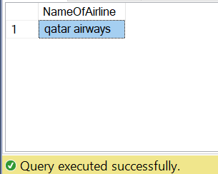

1. Concatenate airline id and name of airline from table Details_Of_Airline.

Select concat(id_of_airline,' ',name_of_airline) as ID_Name_Of_Airlines from Details_Of_Airline

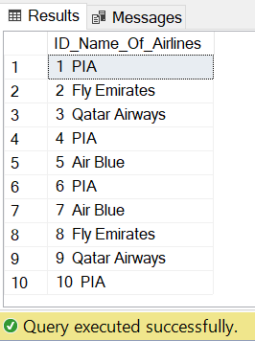

1. Showing name of airline from table Details_Of_Airline. Where id =3

Select reverse(name_of_airline) as Name_Of_Airlines from Details_Of_Airline where id_of_airline = 3

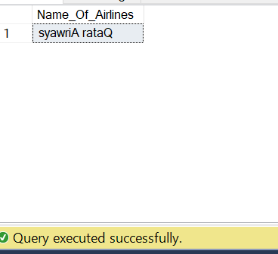

1. Display passenger first name and last name in format with only first letter from first name in capital, space and then Last name with first letter in caps( i.e display Zunaira javaid in Z Javaid).

create function Name_of_passenger(@f nvarchar(200),@l nvarchar(200))

returns nvarchar(max)

as

begin

declare @y nvarchar(max)

set @y=UPPER(SUBSTRING(ltrim(@f),1,1))+' '+UPPER(SUBSTRING(ltrim(@l),1,1))+SUBSTRING(ltrim(@l),2,len(ltrim(@l)))

return @y

End

select dbo.Name_of_passenger(first_name,last_name) as fullName from Passenger_Info

sp_helptext Name_of_passenger

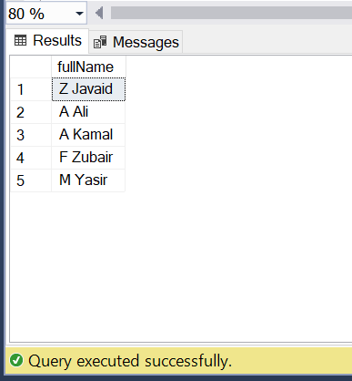

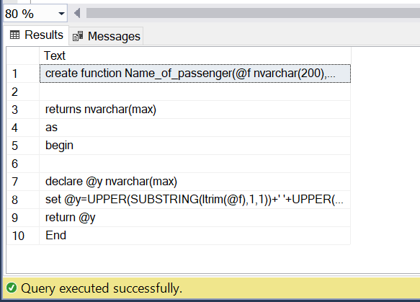

1. Write a query to increment price of ticket if ticket is generated ticket then 10000 incr,then not

genetaed ticket no increment in price.

* Select status_of_ticket,price_of_ticket as increment_without_price_of_ticket,

case

when (status_of_ticket like 'Generated')

then (price_of_ticket +10000)

else price_of_ticket

End as increment_with_price_of_ticket from Ticket_Booking_Info tb join Flight f on tb.ticket_id = f.flight_id

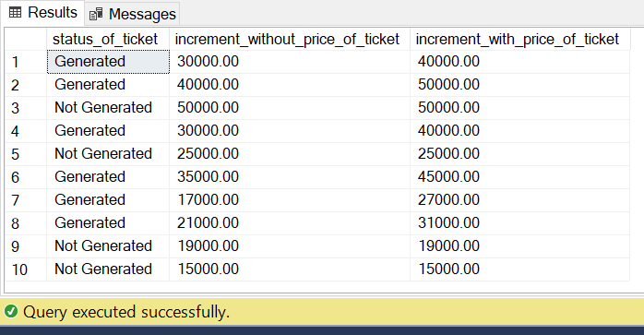

1. Write a query to display total number of flights for each airline.

* Select name_of_airline as airline_name,count(flight_id) as flight_id from Details_Of_Airline a join Det_Airline_Flight af on a.id_of_airline= af.id_of_airline group by name_of_airline

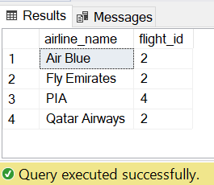

1. Write a query to passenger name and display total number of tickets of passenger.

* Select concat(first_name,' ',last_name) as full_name,count(ticket_id) as Ticket_id from Passenger_Info p join Passenger_And_Ticket pt

on p.passenger_id = pt.passenger_id group by first_name,last_name

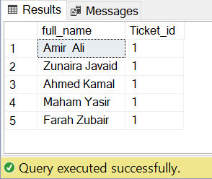

1. Write a query to create view showing id_of_airline, name_of_airline ,total_no_of_seats, from_location, to_location, departure_time ,arrival_time,flight_duration of table Details_Of_Airline where name_of_airline equal to “PIA”.

* Create view DeatailsAirline

as

select id_of_airline, name_of_airline ,total_no_of_seats, from_location, to_location, departure_time ,arrival_time,flight_duration from

Details_Of_Airline where name_of_airline='PIA'

Select *from Passenger_Info

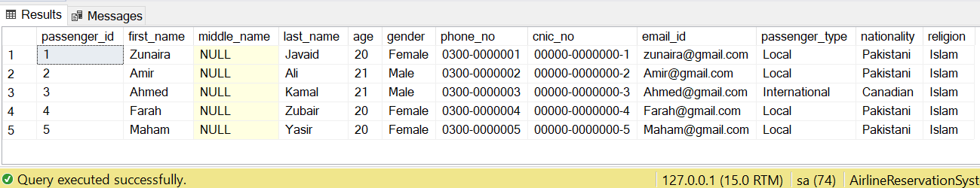

## Conclusion

In the end to conclude, we can say it is a single platform where a user can check, book, compare and availability of seats in our system. We provide the least rates and on the booking panel we also show and let the user compare the prices with other airlines of our level of efficiency. We’re providing online payment methods, accepting every international bank cards. In our system we allow the users to locate and check on their flight through our tracking Id number.

## List of tasks assigned:

* **Task 1:** Gathering Requirements
* **Task 2:** Introduction & Business Case
* **Task 3:** ERD & Relational Model
* **Task 4:** Schema Map
* **Task 5:** Table Plans
* **Task 6:** DDL Commands
* **Task7:** DML Commands
* **Task8:**SQL Quires

## 